# The Complete MySQL Developer Course–Whole Practice Assignment

**Problem:**

**A.** Write the query to create the table and insert the data into the table and fetch the data from the table. Using order by and group by and find minimum and maximum value in the table .

**B.** Write the query based on the data types in MySQL database and use functions Date and Times and

Write the query to fetch the data from two or more tables using joins and use primary and foreign key in MYSQL database.

**C.** Write the program to develop the application using HTML and add the style in the application using CSS.

**Solution:**

**A.** Write the query to create the table and insert the data into the table and fetch the data from the table. Using order by and group by and find minimum and maximum value in the table .

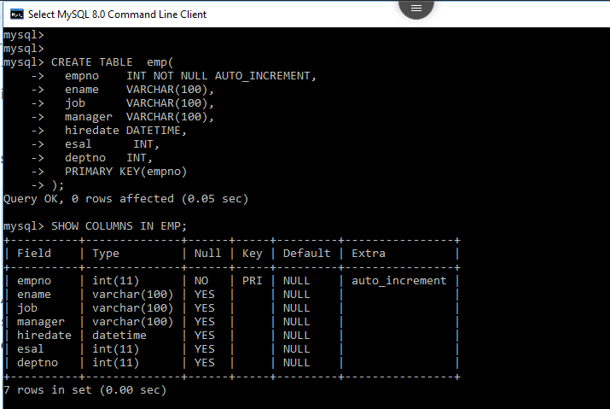

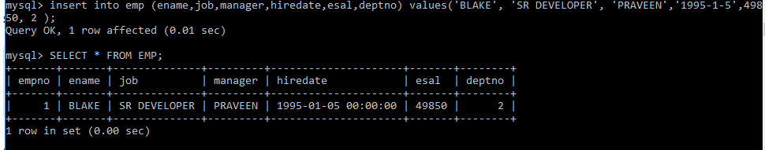

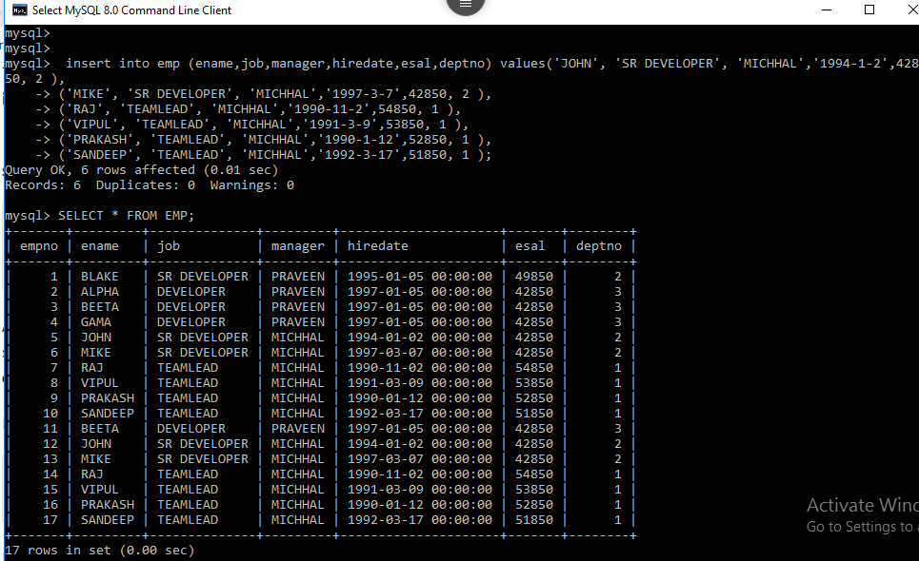

1)Display the COUNT, SUM, MIN, MAX of any numeric column in a table.

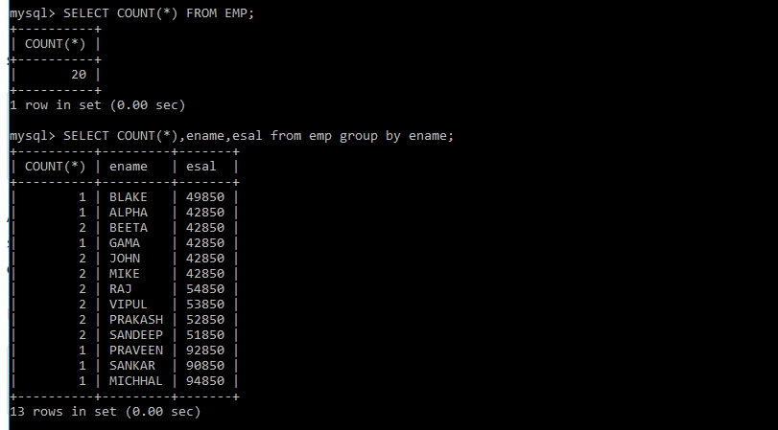

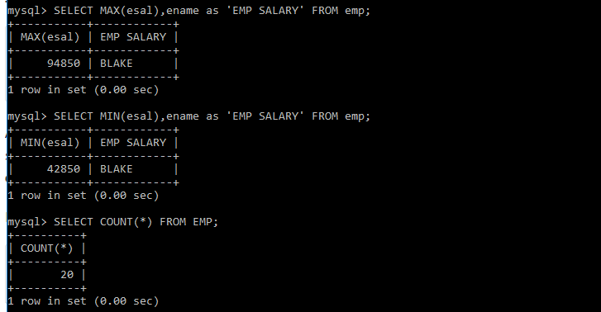

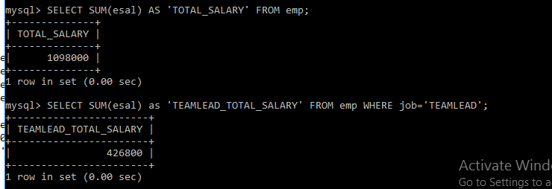

2) Display the Sum of a column using GROUP BY.

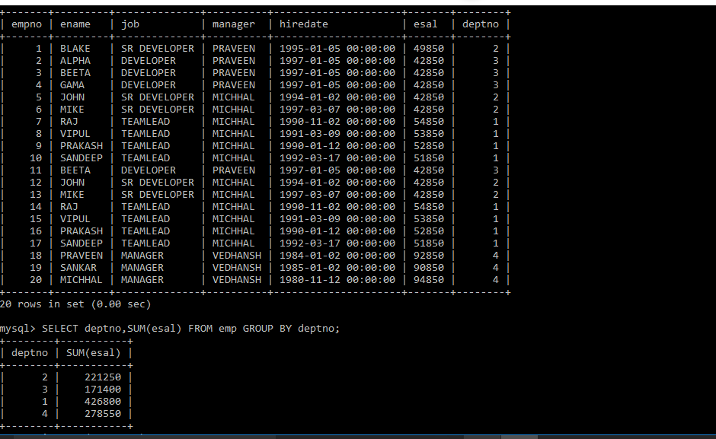

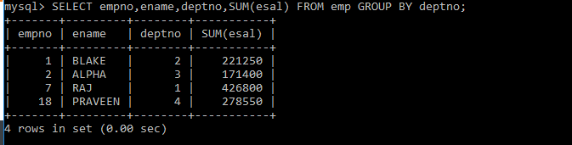

3) Restrict the GROUPs using HAVING so that only the TOP most group is displayed.

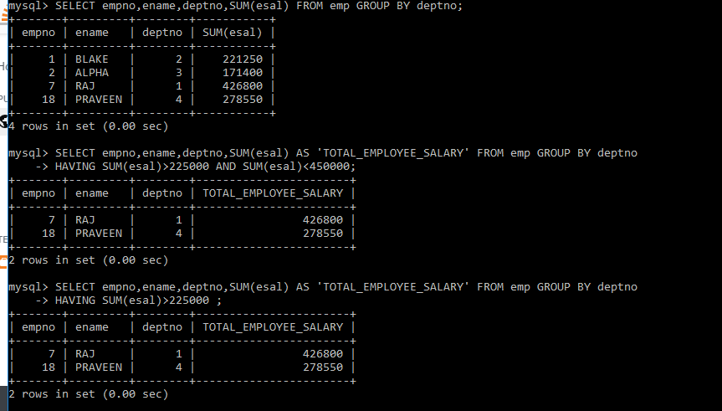

4) Display the first 5 and last 5 records from the table. (Hint: use row num and UNION).

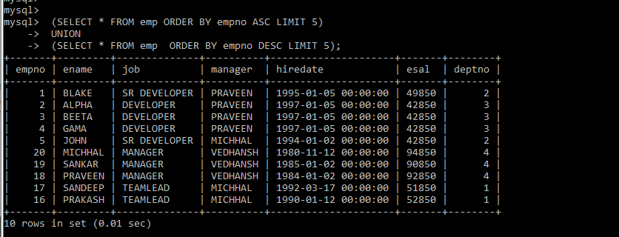

**B.** Write the query based on the data types in MySQL database and use functions Date and Times and

Write the query to fetch the data from two or more tables using joins and use primary and foreign key in MYSQL database.

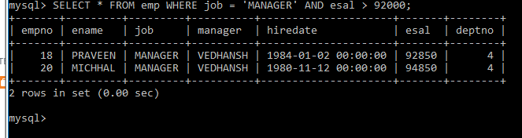

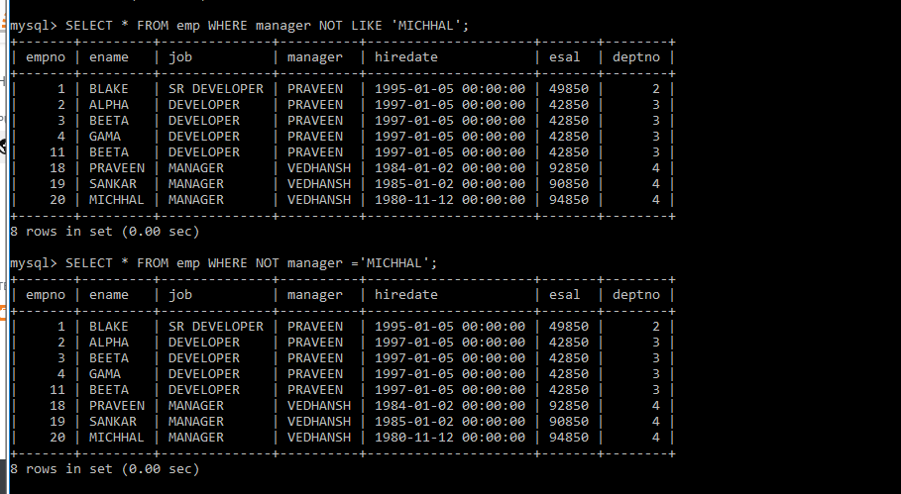

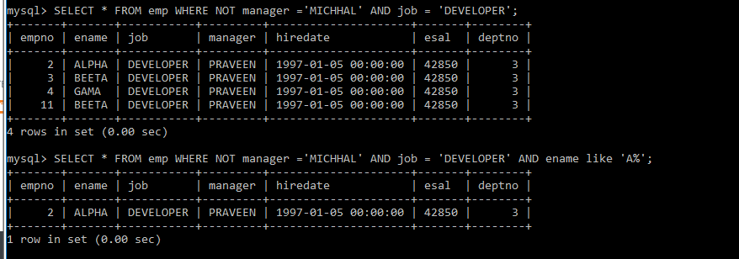

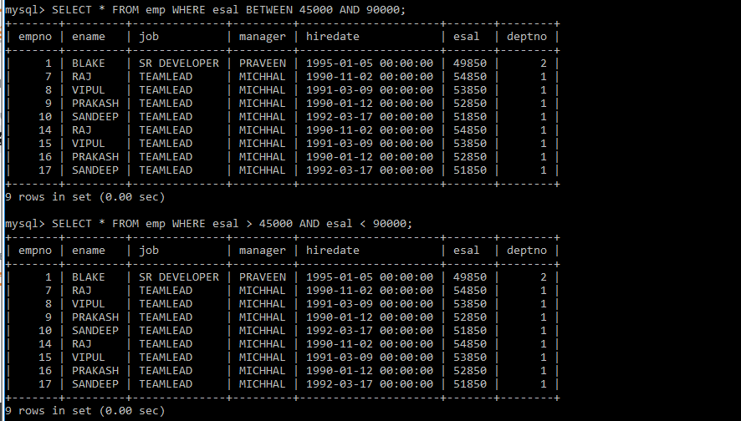

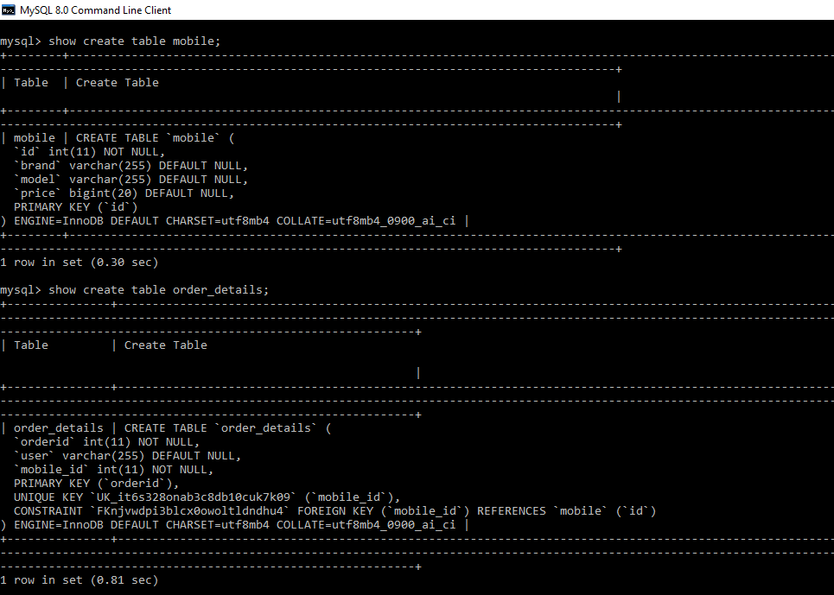



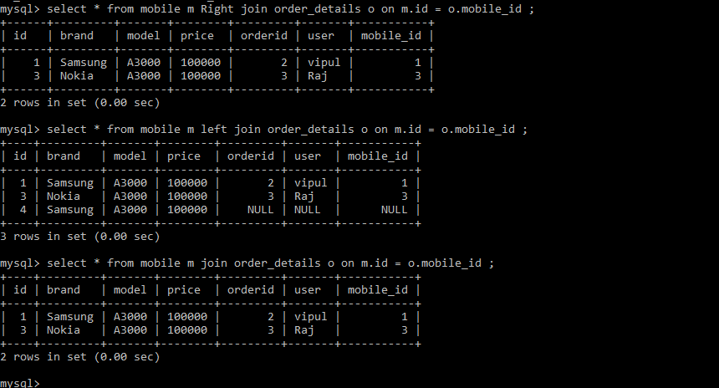

**C.** Write the program to develop the application using HTML and add the style in the application using CSS.

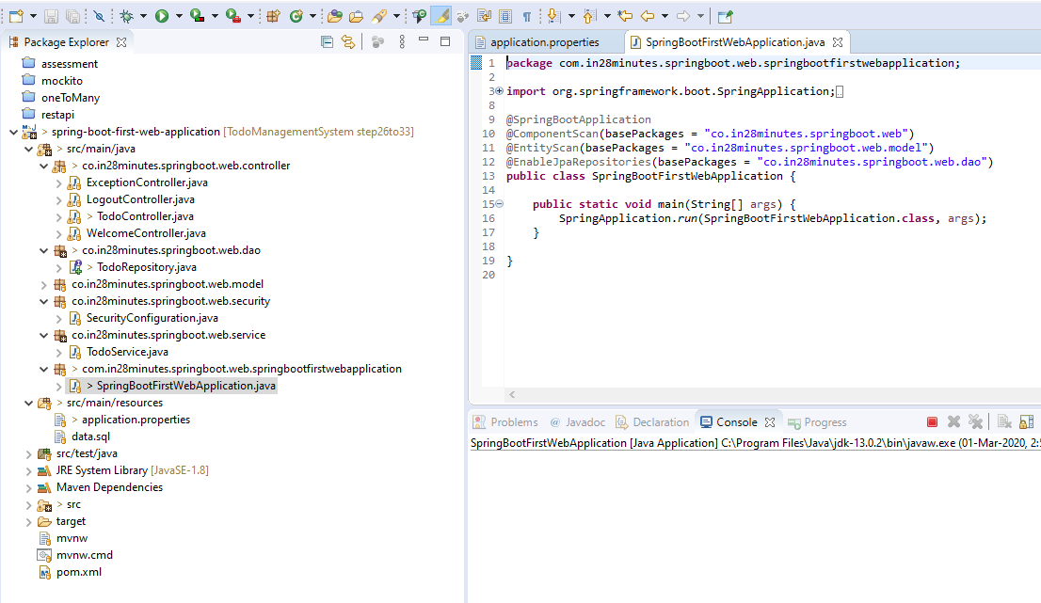

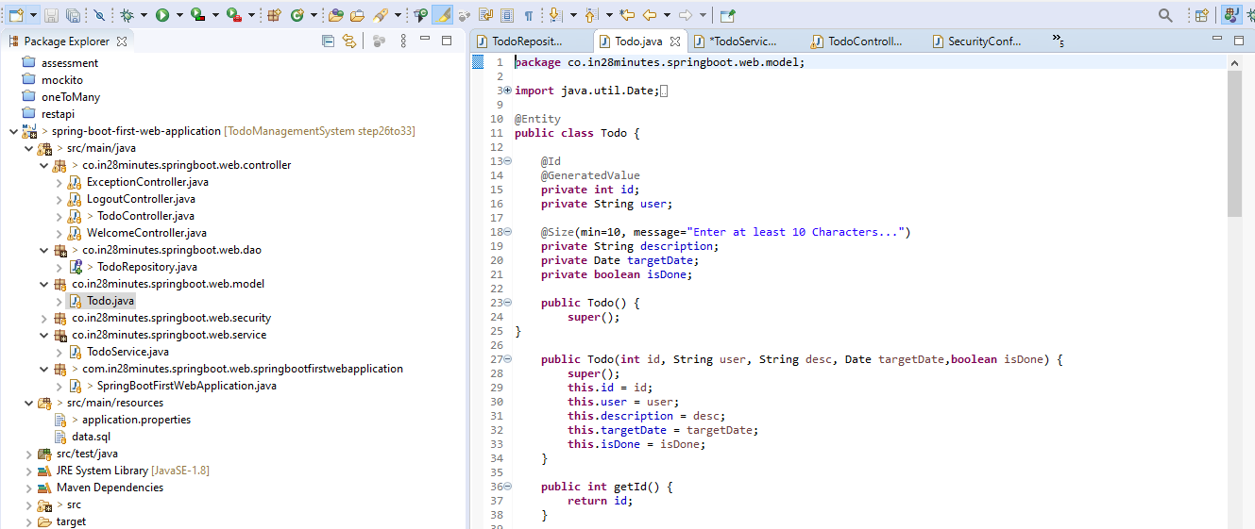

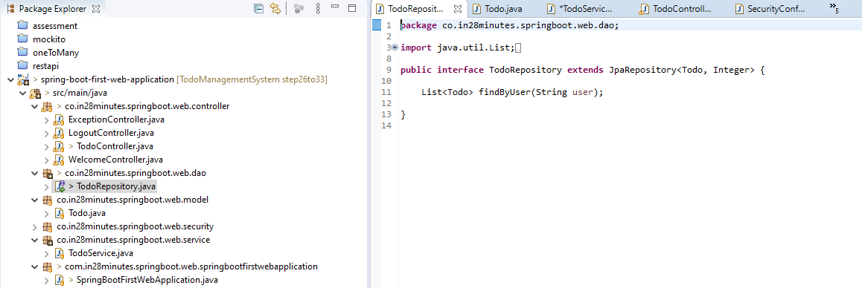

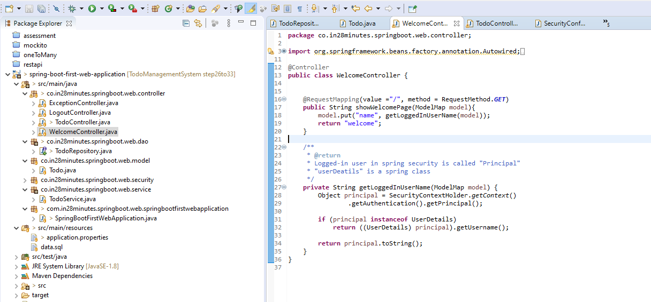

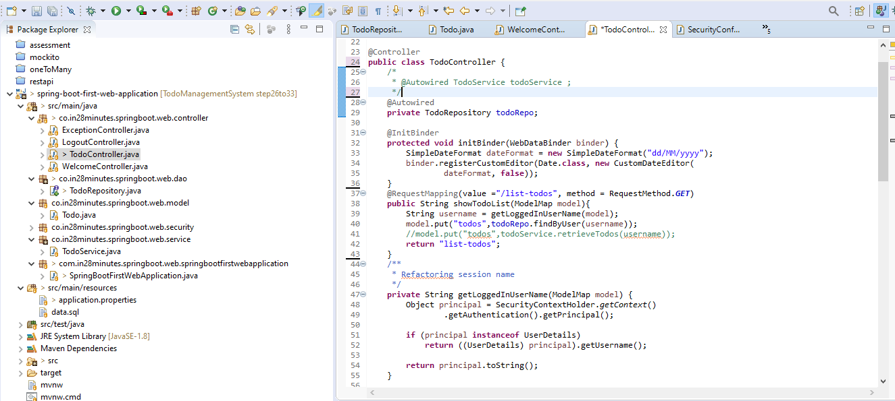

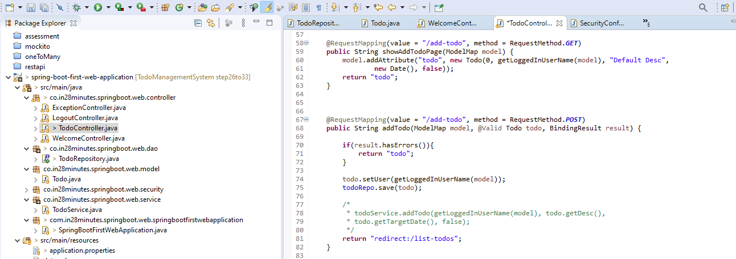

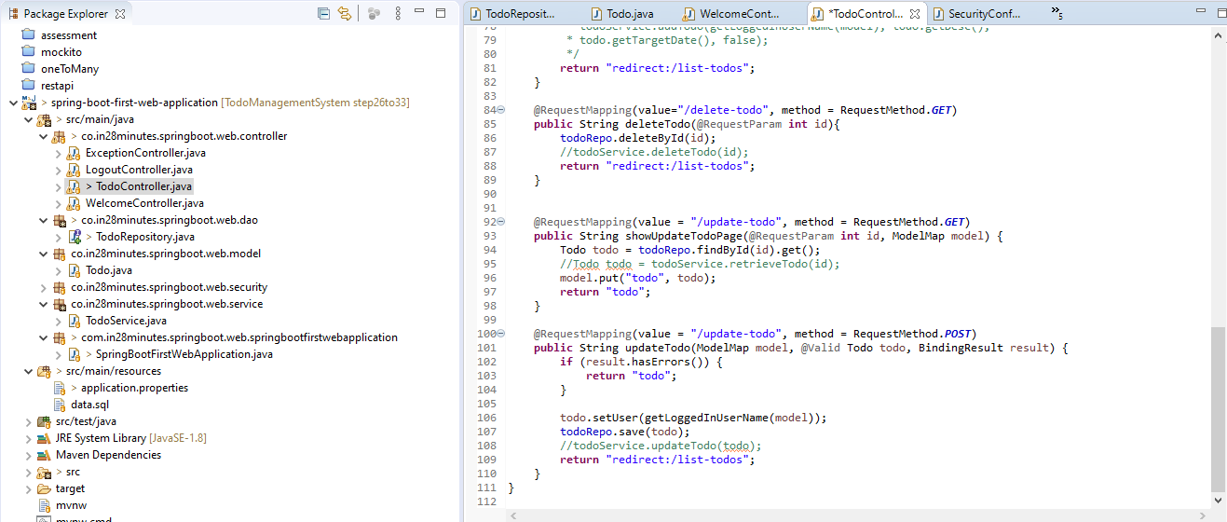

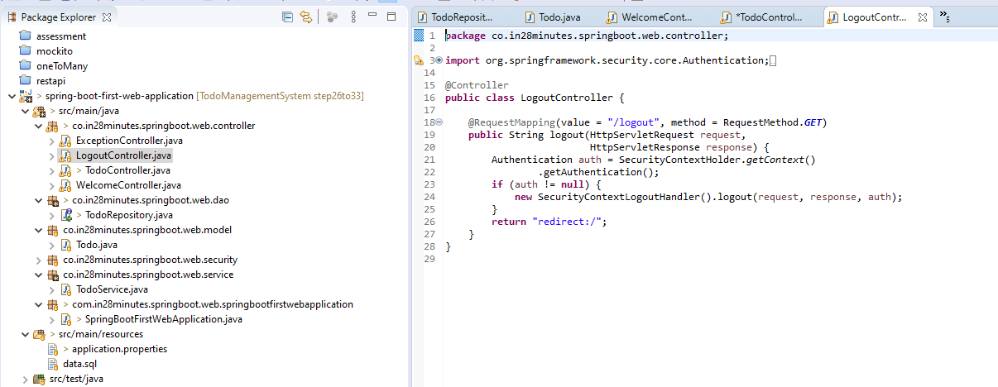

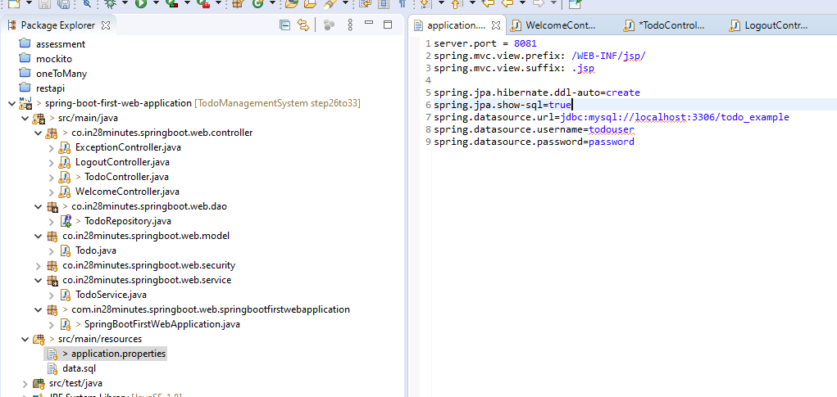

Execution:





Add :



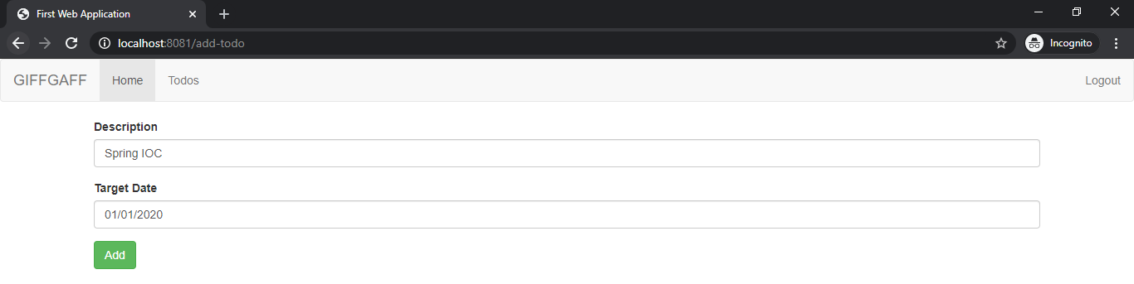

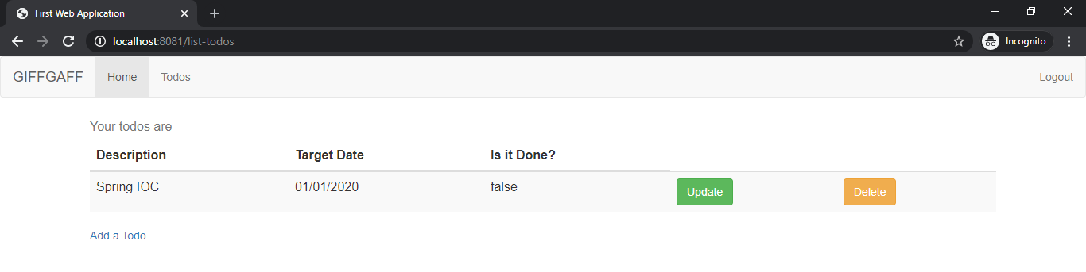

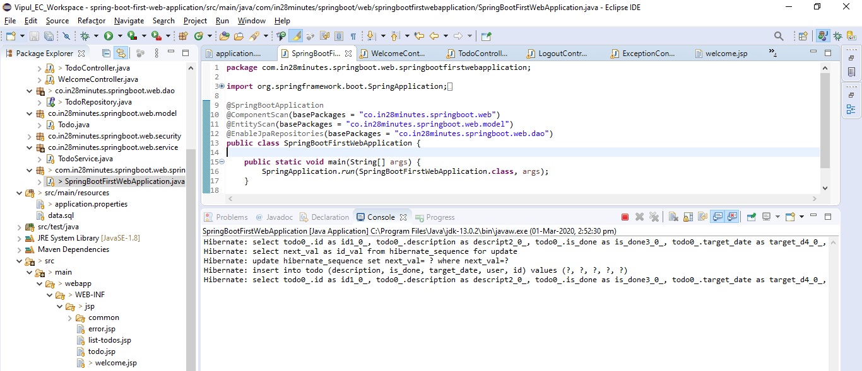

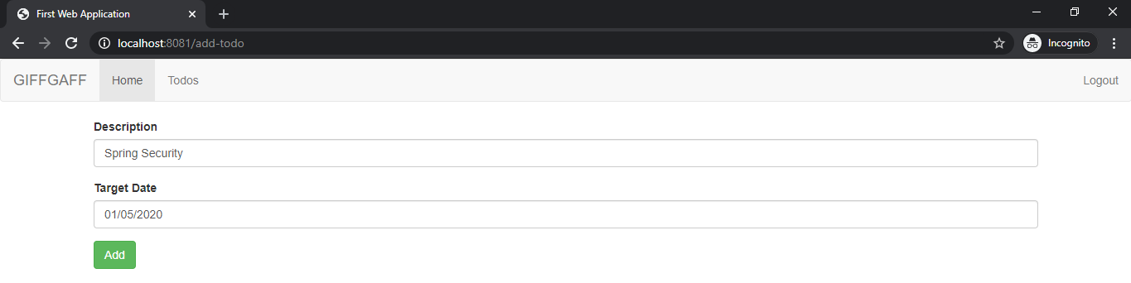

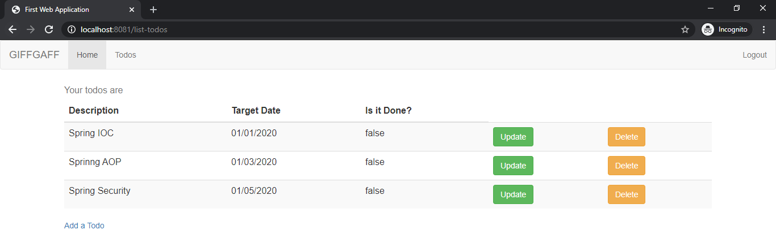

Update:

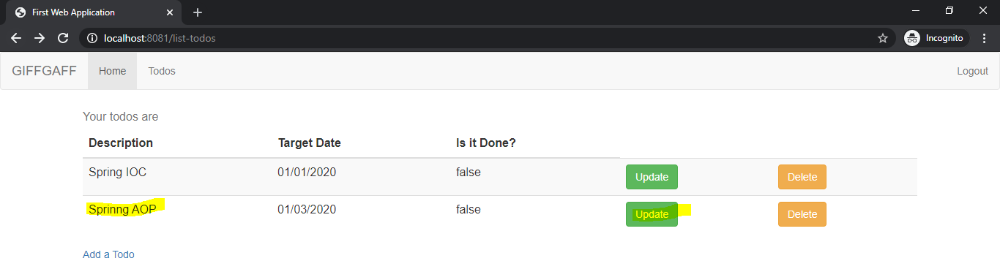

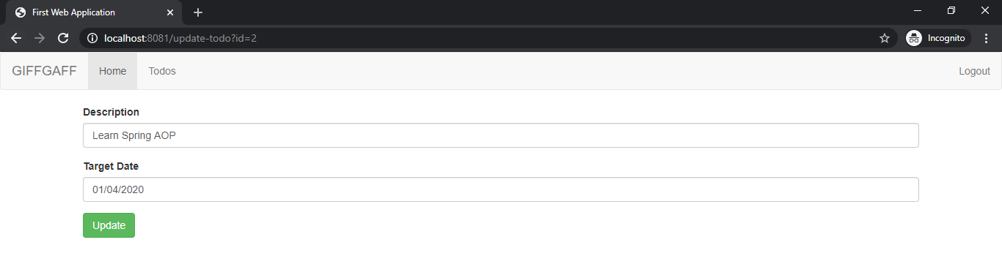

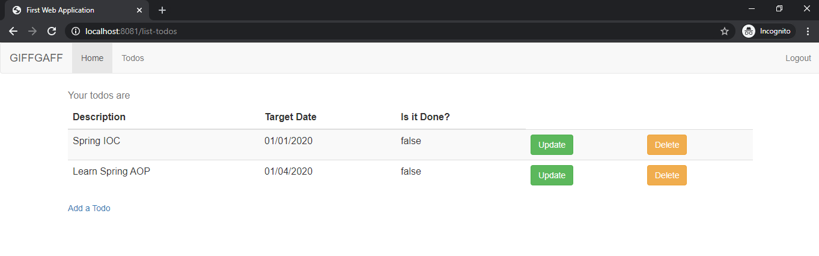

Delete:

